**Project Design Phase-II**

**Smart Sorting : Transfer Learning For Identifying**

**Rotten Fruits and Vegetables**

**(Data Flow Diagram & User Stories)**

|  |  |
| --- | --- |
| Date | 27 June 2025 |
| Team ID | LTVIP2025TMID59297 |
| Project Name | Smart sorting: transfer Learning For Identifying Rotten Fruits and Vegetables |
| Maximum Marks | 4 Marks |

**Data Flow Diagrams:**A Data Flow Diagram (DFD) is a traditional visual representation of the information flows within a system. A neat and clear DFD can depict the right amount of the system requirement graphically. It shows how data enters and leaves the system, what changes the information, and where data is stored.

**DFD:**

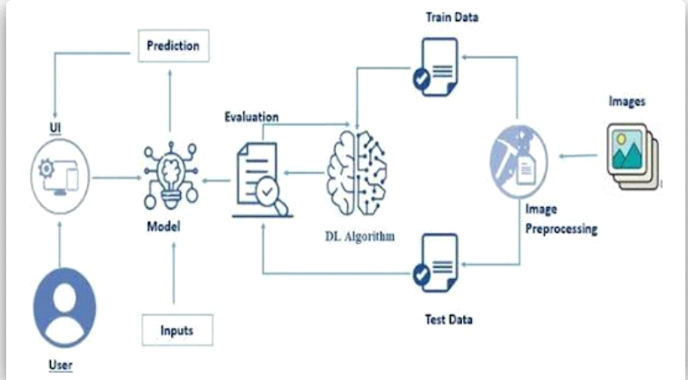

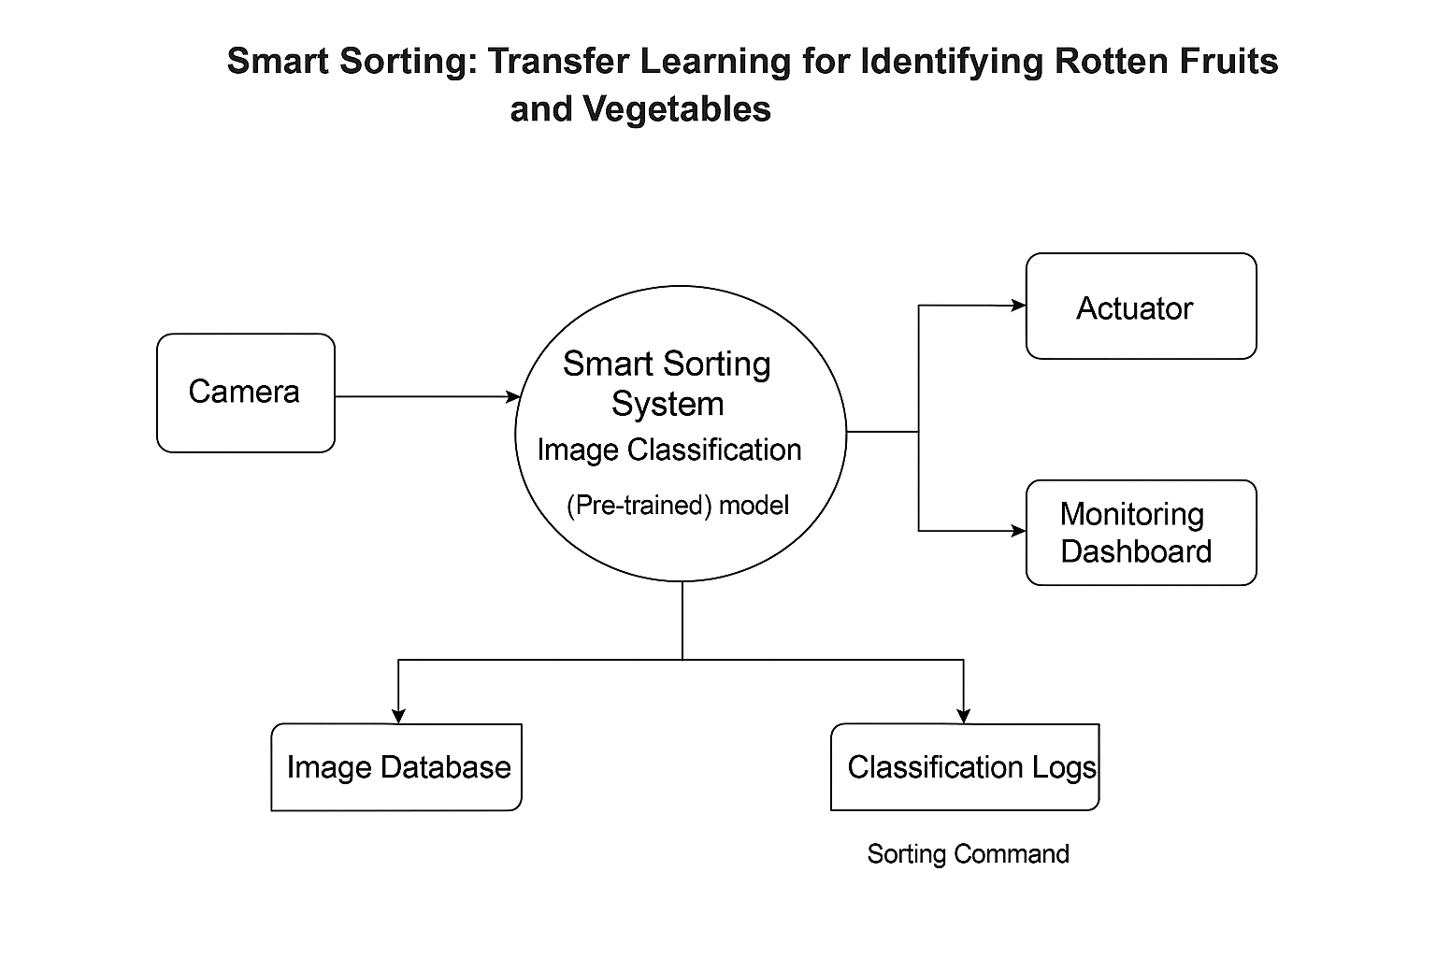

**User Stories**

Use the below template to list all the user stories for the product.

|  |  |  |  |  |  |  |
| --- | --- | --- | --- | --- | --- | --- |
| **User Type** | **Functional Requirement (Epic)** | **User Story Number** | **User Story / Task** | **Acceptance criteria** | **Priority** | **Release** |
| Quality Control Manager | Image Classification | USN-1 | As a quality manager, I can view alerts when rotten items are detected. | Alert appears when rotten item is classified. | High | Sprint-1 |
| Quality Control Manager | Dashboard Monitoring | USN-2 | As a manager, I can monitor real-time sorting data on a dashboard. | Live feed shows number of rotten vs fresh items sorted. | High | Sprint-1 |
| System (Machine Vision) | Image Capture and Processing | USN-3 | As the system, I can capture and process images of fruits and vegetables using cameras and send them for classification. | Every frame is analyzed; processed images are labeled | High | Sprint-1 |
| Administrator | Model Training | USN-4 | As an admin, I can upload new training data to retrain the transfer learning model. | New data accepted and model retrained successfully. | Medium | Sprint-2 |
| Warehouse Supervisor | Report Generation | USN-5 | As a supervisor, I can generate daily and weekly reports of sorting results. | Reports show counts of fresh vs rotten items with timestamps. | Medium | Sprint-2 |
| Smart Fridge User (Home) | Spoilage Notification | USN-6 | As a user, I receive notifications if any stored produce is detected as spoiling. | Notification is triggered for any spoiled item in the fridge. | High | Sprint-2 |